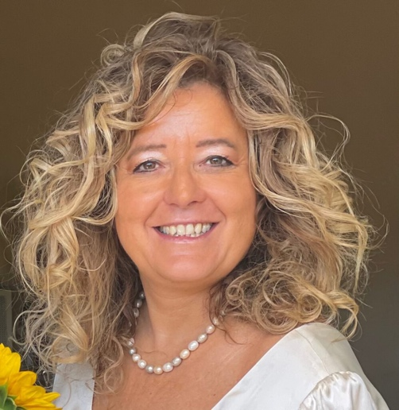
Gabriella M. Racca is Full Professor of Administrative Law at the Department of Management of the University of Torino (Italy). She coordinates the IUS Publicum Network Review (class A ranking) and she is a member of many international networks. She is in the Board of Directors of the Italian Institute of Administrative Sciences (I.I.A.S.). She is the Director of the Master on Efficiency, Integrity and Innovation in Italian Public contracts (Master SEIIC), mentioned by the EU Commission as an example of training in public procurement/anti-corruption issues. She teaches in different master programs, among which Master in Public Procurement Management for sustainable development and Master en gouvernance et management des marchés publics en appui au développement durable (both organized by the ITC-ILO and University of Torino). Since the first edition, she has thaught in the diploma/master in “Public procurement regulation in the EU and its global context” (organized by Centre of European Law, The Dickson Poon School of Law, King’s College London).
She has been Head of Research Units of several EU projects PPI2Innovate, CirPro, Finch and Healthy Ageing and Public Procurement of Innovation and Member of the Advisory Board of the EURIPHI project. At the moment, she is Advisory Partner of the Interreg EU Project "Supporting the integration of New European Bauhaus values and principles into the regional planning processes" (NEBA).
She collaborates with different Colleagues of international Universities on many research topics as Administrative Law, Public liability, Integrity, Public Procurement and innovation, digital transition and aggregation models.
Publications are available in Open Access here and on SSRN Page.

